Setting:

/10

Themes:

/10
Lighting:

/5

Colour:

/5

Juxtaposition:

/10
Shot selection:

/5
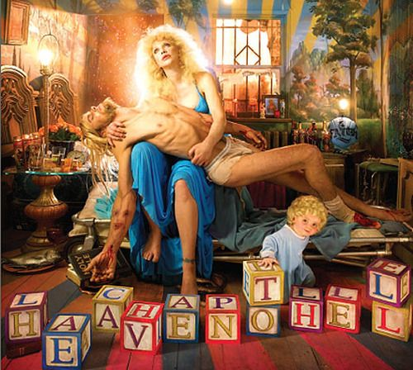

Technical Composition:

/5

Symbolism:

/15

David LaChapelle influences:

/5

Vectors (Leading Lines):

/10
Written Code (Text):

/5
Allusions of Religious Iconography:

/10
Popular Culture History:

/5

